**Q51. Write an SQL query to report the name, population, and area of the big countries. Return the result table in any order**

create table world

(name varchar(20),

continent varchar(20),

area int,

population int,

gdp bigint,

primary key(name)

)

insert into world values

('Afghanistan', 'Asia' ,652230 ,25500100 ,20343000000),

('Albania', 'Europe', 28748, 2831741 ,12960000000),

('Algeria', 'Africa', 2381741 ,37100000 ,188681000000),

('Andorra' ,'Europe', 468, 78115, 3712000000),

('Angola', 'Africa' ,1246700 ,20609294 ,100990000000)

select name , area, population from world order by population desc limit 2 ;

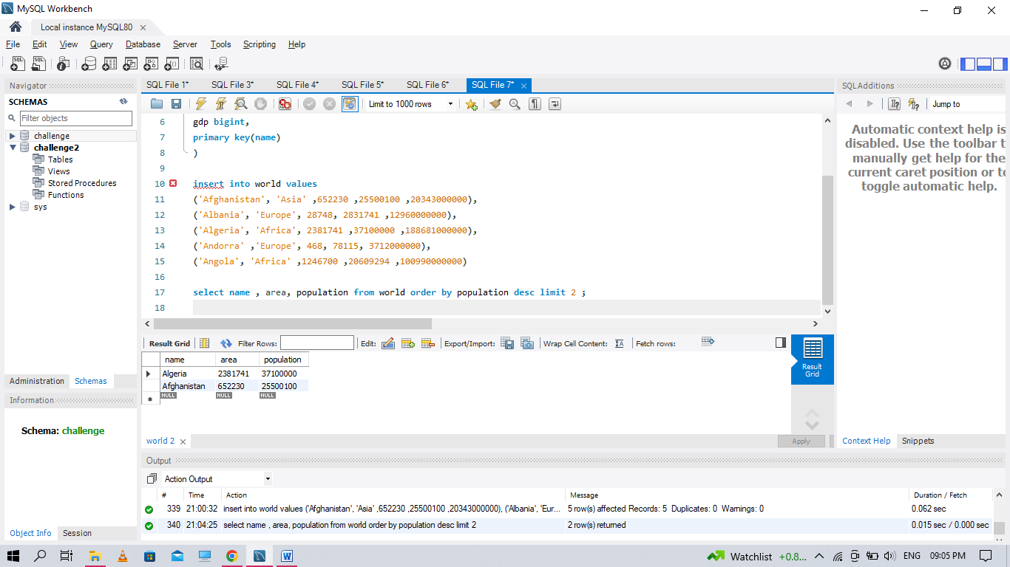

**Q52. Write an SQL query to report the names of the customer that are not referred by the customer with id = 2**

create table customer

(id int,

name varchar(20),

referee_id int,

primary key(id)

)

insert into customer values

(1 ,'Will' ,null),

(2 ,'Jane' ,null),

(3 ,'Alex' ,2),

(4 ,'Bill' ,null),

(5 ,'Zack' ,1),

(6 ,'Mark' ,2)

select name from customer where referee_id <> 2 or referee_id is null;

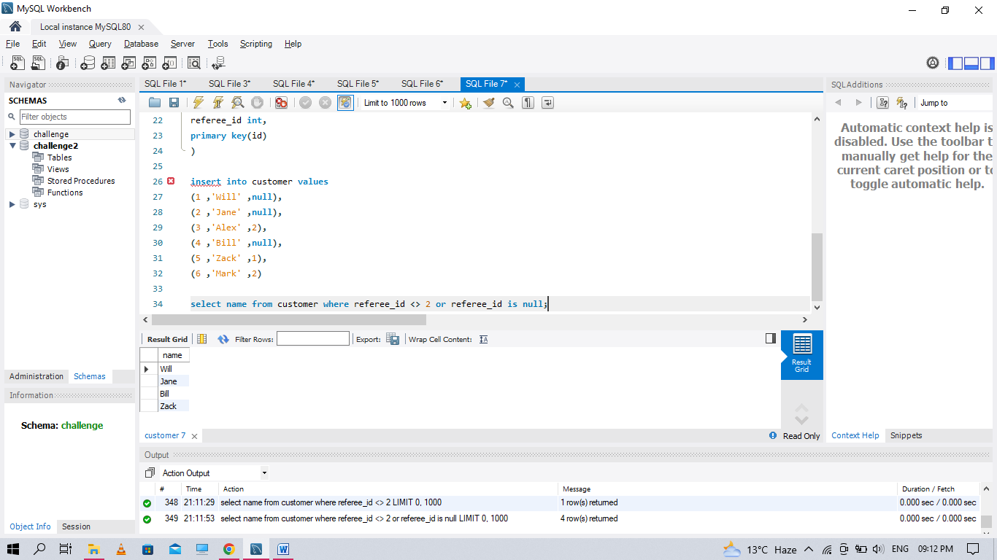

**Q53. Write an SQL query to report all customers who never order anything. Return the result table in any order.**

create table customers

(id int,

name varchar(20),

primary key(id))

create table orders

(id int,

customer_id int,

primary key(id))

insert into customers values

(1 ,'Joe'),

(2,'Henry'),

(3 ,'Sam'),

(4 ,'Max')

insert into orders values

( 1, 3),(2, 1)

select c.name from customers c

where id not in (

select customer_id from orders)

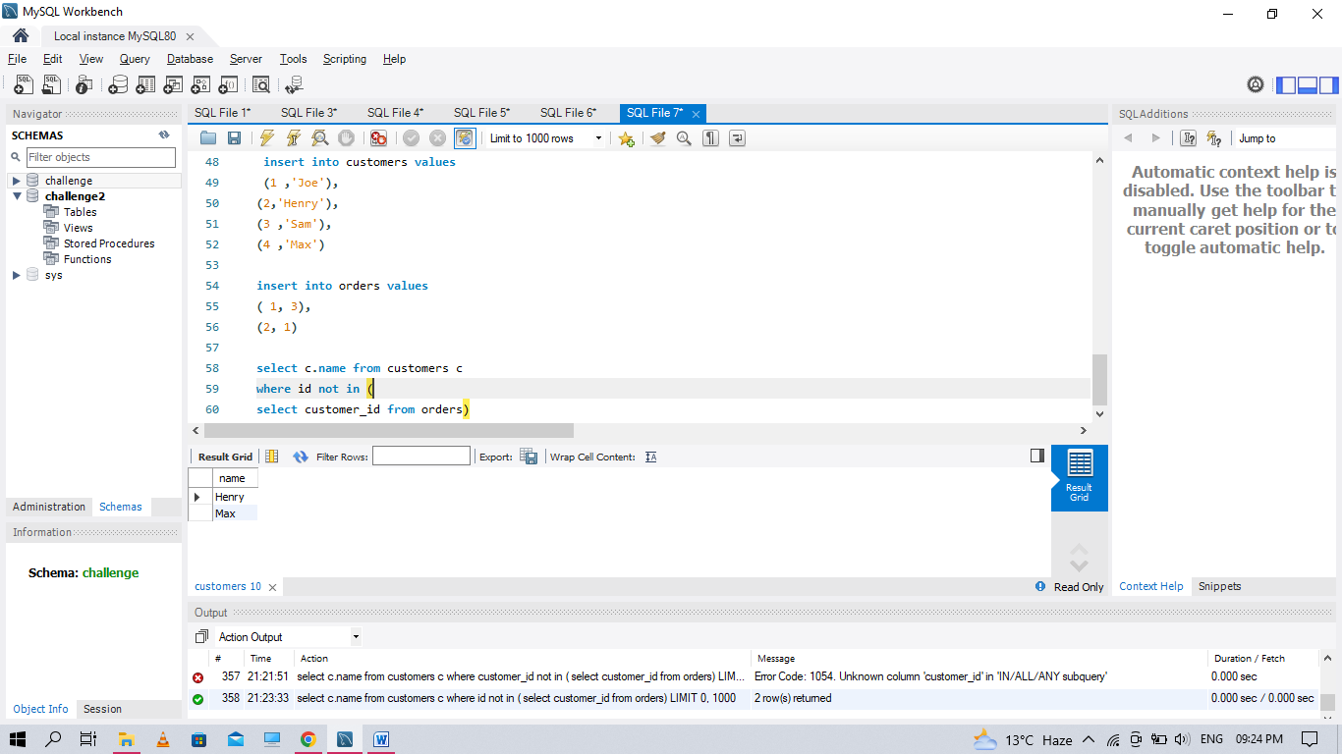

**Q54. Write an SQL query to find the team size of each of the employees. Return result table in any order.**

create table employeee

(employee_id int,

team_id int,

primary key(employee_id)

)

insert into employeee values

(1, 8),

(2, 8),

(3, 8),

(4, 7),

(5, 9),

(6, 9)

select employee_id , COUNT(team_id) OVER (PARTITION BY team_id) team_size

FROM Employeee

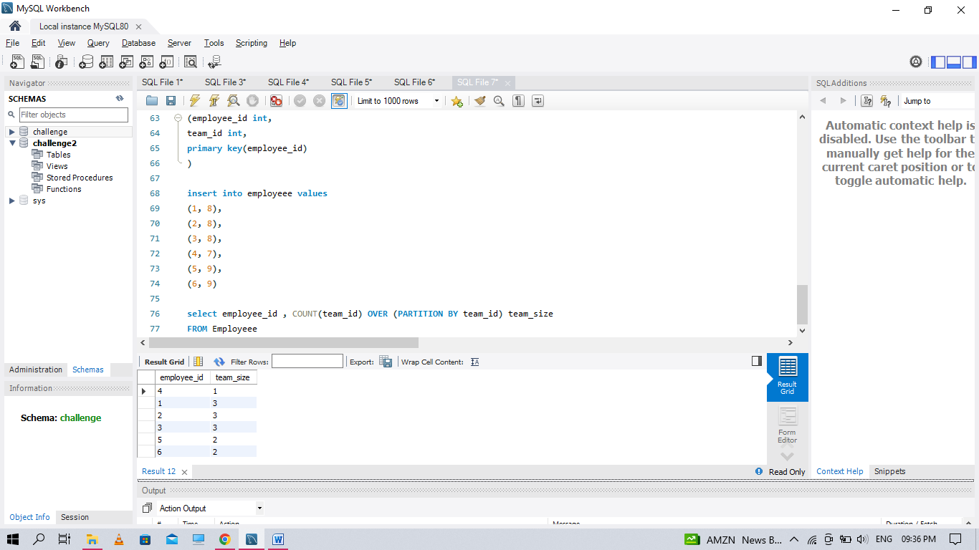

Q55. Write an SQL query to find the countries where this company can invest. Return the result table in any order.

create table person

(

id int,

name varchar(20),

phone_number varchar(20),

primary key(id)

)

create table country

(

name varchar(20),

country_code varchar(20),

primary key(country_code)

)

create table calls

(caller_id int,

callee_id int,

duration int

)

insert into person values

(3 ,'Jonathan', '051-1234567'),

(12 ,'Elvis' ,'051-7654321'),

(1 ,'Moncef' ,'212-1234567'),

(2 ,'Maroua' ,'212-6523651'),

(7 ,'Meir' ,'972-1234567'),

(9 ,'Rachel' ,'972-0011100')

insert into country values

('Peru' ,'51'),

('Israel' ,'972'),

('Morocco' ,'212'),

('Germany' ,'49'),

('Ethiopia' ,'251')

insert into calls values

(1 ,9 ,33),

(2 ,9 ,4),

(1 ,2 ,59),

(3 ,12 ,102),

(3 ,12 ,330),

(12 ,3 ,5),

(7 ,9 ,13),

(7 ,1 ,3),

(9 ,7 ,1),

(1 ,7 ,7)

select c.name as country

from Person p

inner join Country c

on left (p.phone_number,3) = c.country_code

inner join (select caller_id as id, duration

from Calls

union all

select callee_id as id, duration

from Calls) phn

on p.id = phn.id

group by country

having avg(duration) > (select avg(duration) from Calls)

**Q56. Write an SQL query to report the device that is first logged in for each player. Return the result table in any order.**

create table Activity

(

player_id int,

device_id int,

event_date date,

games_played int,

primary key (player_id, event_date))

insert into activity values

(1 ,2, '2016-03-01', 5),

(1 ,2, '2016-05-02' ,6),

(2 ,3, '2017-06-25' ,1),

(3 ,1, '2016-03-02' ,0),

(3 ,4, '2018-07-03' ,5)

SELECT PLAYER_ID , MIN(EVENT_DATE)

FROM ACTIVITY

GROUP BY PLAYER_ID;

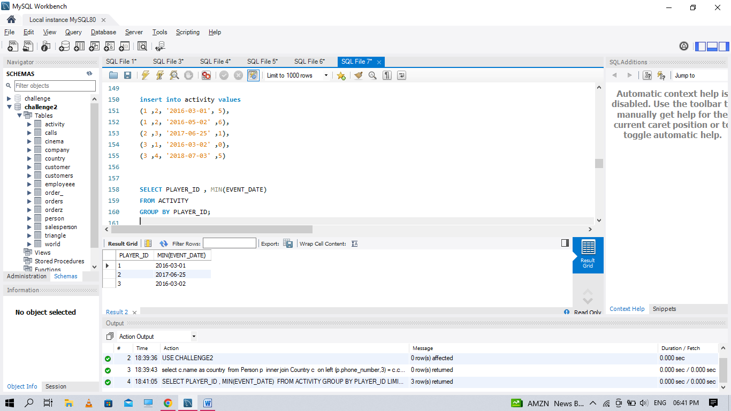

**Q57 Write an SQL query to find the customer_number for the customer who has placed the largest number of orders.**

CREATE TABLE ORDER_

(order_number int,

customer_number int,

PRIMARY KEY(order_number)

)

INSERT INTO ORDER_ VALUES

(1, 1),

(2 ,2),

(3 ,3),

(4 ,3)

select

customer_number

from

(select customer_number, count(order_number) order_count

from order_ group by customer_number) a

order by order_count desc limit 1

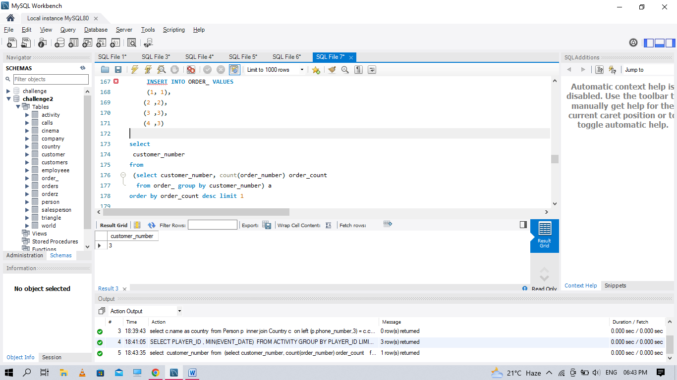

**Q58 Write an SQL query to report all the consecutive available seats in the cinema**

CREATE TABLE CINEMA

(seat_id int NOT NULL AUTO_INCREMENT ,

free bool,

PRIMARY KEY (seat_id)

)

INSERT INTO CINEMA VALUES

(1 ,1),

(2 ,0),

(3 ,1),

(4 ,1),

(5 ,1)

SELECT

DISTINCT t1.seat_id

FROM cinema AS t1 JOIN cinema AS t2

ON abs(t1.seat_id - t2.seat_id) = 1

AND t1.free = 1 AND t2.free = 1

ORDER BY 1

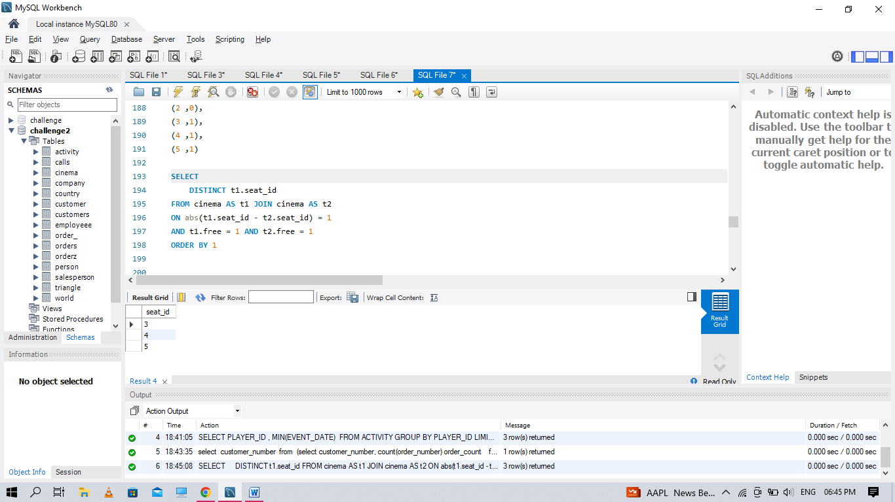

**Q59 Write an SQL query to report the names of all the salespersons who did not have any orders related to the company with the name "RED".**

CREATE TABLE COMPANY

(com_id int,

name varchar(30),

city varchar(30),

PRIMARY KEY(com_id))

CREATE TABLE ORDERZ

(

order_id int,

order_date date,

com_id int,

sales_id int,

amount int,

PRIMARY KEY (order_id),

FOREIGN KEY (com_id) REFERENCES COMPANY(com_id)

)

CREATE TABLE SALESPERSON

(sales_id int,

name varchar(30),

salary int,

commission_rate int,

hire_date date,

PRIMARY KEY(sales_id)

)

INSERT INTO SALESPERSON VALUES

(1, 'John' ,100000, 6 ,'2006-01-04'),

(2, 'Amy' ,12000 ,5 ,'2010-01-05'),

(3, 'Mark' ,65000 ,12, '2008-12-25'),

(4, 'Pam' ,25000 ,25 ,'2005-01-01'),

(5, 'Alex' ,5000 ,10 ,'2007-03-02')

INSERT INTO COMPANY VALUES

(1, 'RED', 'Boston'),

(2, 'ORANGE', 'New York'),

(3, 'YELLOW' ,'Boston'),

(4, 'GREEN' ,'Austin')

INSERT INTO ORDERZ VALUES

(1, '2014-01-01', 3, 4, 10000),

(2, '2014-01-02', 4, 5, 5000),

(3, '2014-01-03', 1, 1, 50000),

(4, '2014-01-04', 1, 4, 25000)

SELECT NAME

FROM SALESPERSON WHERE SALES_ID NOT IN (SELECT S.SALES_ID FROM SALESPERSON S INNER JOIN ORDERZ O

ON O.SALES_ID=S.SALES_ID INNER JOIN COMPANY C ON O.com_id=C.com_id WHERE C.NAME ='red')

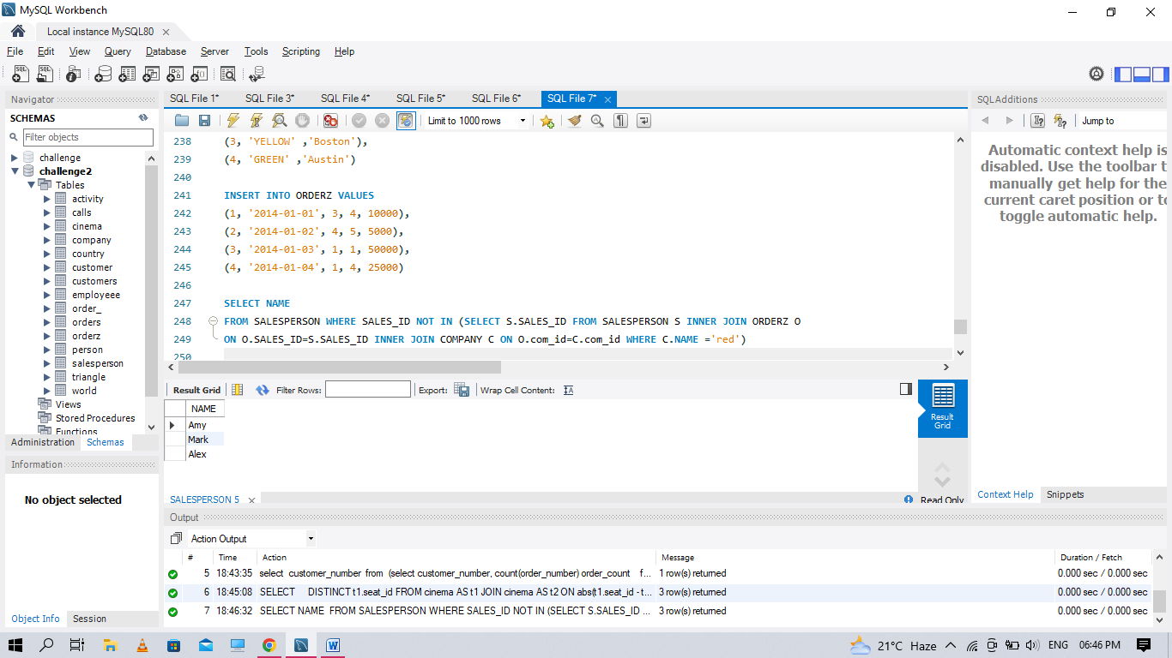

**Q60. Write an SQL query to report for every three line segments whether they can form a triangle. Return the result table in any order.**

CREATE TABLE TRIANGLE

(x int,

y int,

z int,

PRIMARY KEY(X,Y,Z))

INSERT INTO TRIANGLE VALUES

(13, 15, 30),

(10, 20,15)

SELECT

x, y, z,

IF(x + y > z AND y + z > x AND z + x > y, 'Yes', 'No') triangle

FROM triangle;

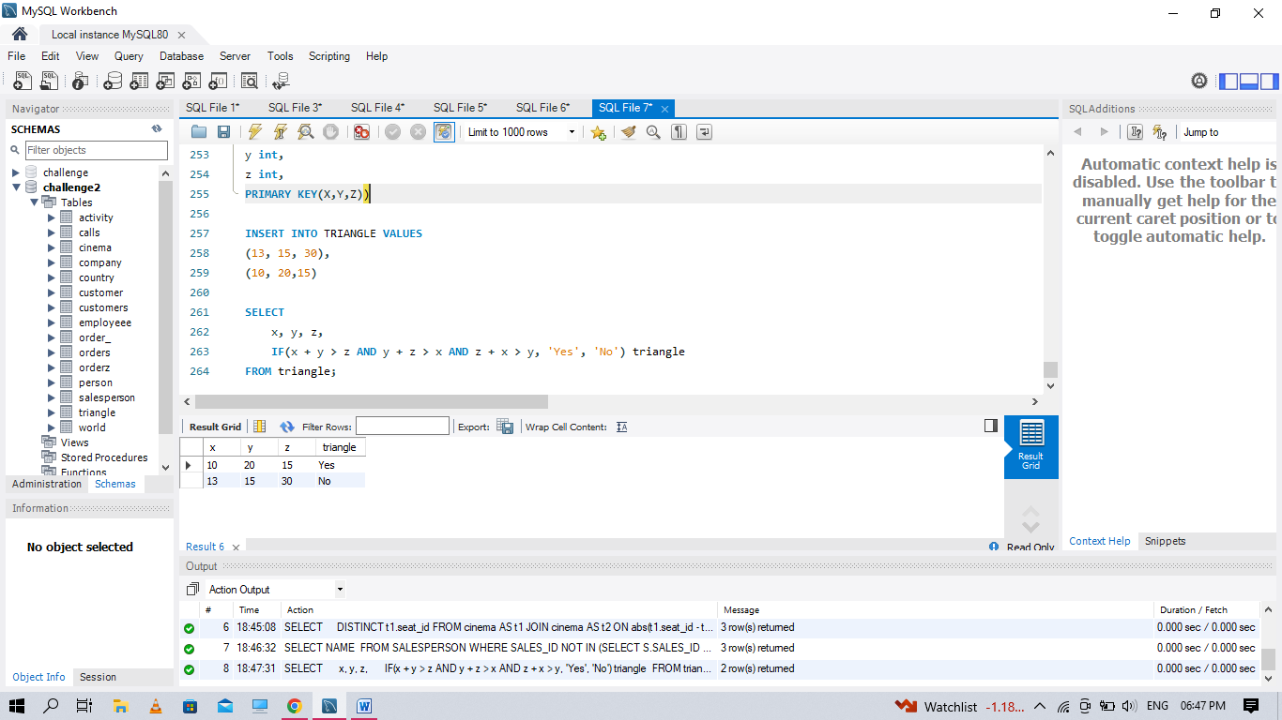

**Q61. Write an SQL query to report the shortest distance between any two points from the Point table. The query result format is in the following example.**

CREATE TABLE POINT(

x int,

PRIMARY KEY (X)

)

INSERT INTO POINT VALUES(-1),(0),(2)

SELECT MIN(X) SHORTEST FROM POINT;

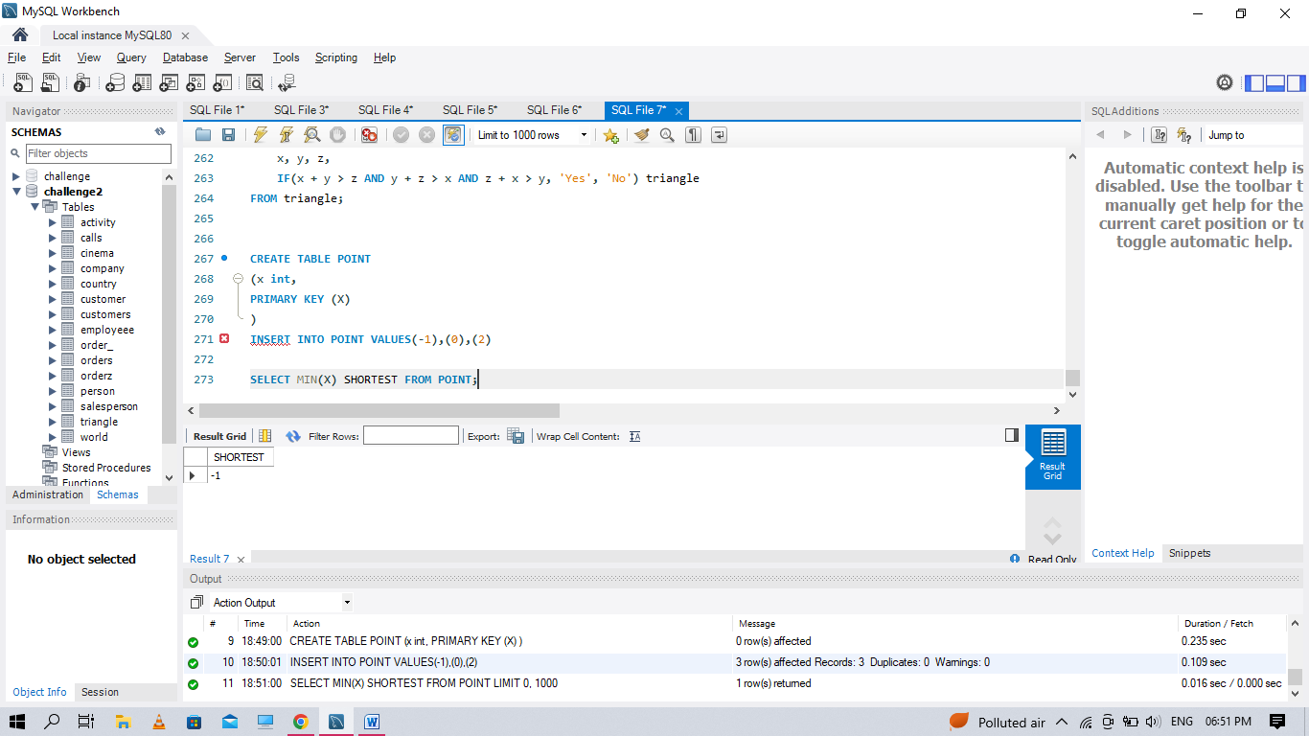

**Q62 Write a SQL query for a report that provides the pairs (actor_id, director_id) where the actor has cooperated with the director at least three times.**

CREATE TABLE ACTORDIRETOR

(actor_id int,

director_id int,

timestamp int,

PRIMARY KEY(timestamp))

INSERT INTO ACTORDIRETOR VALUES

(1, 1, 0),

(1, 1, 1),

(1, 1, 2),

(1, 2, 3),

(1, 2, 4),

(2, 1, 5),

(2, 1, 6)

SELECT actor_id, director_id

FROM ActorDiretor

GROUP BY actor_id, director_id

HAVING COUNT(*) >= 3

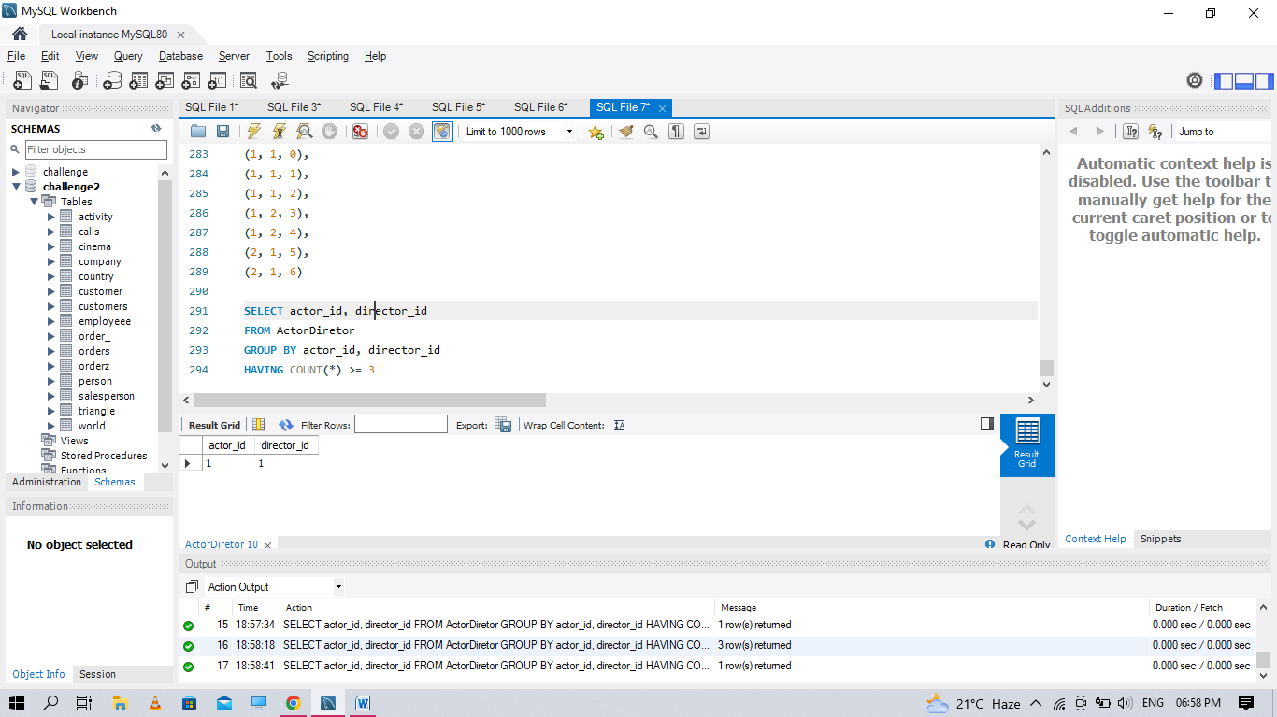

**Q63. Write an SQL query that reports the product_name, year, and price for each sale_id in the Sales table. Return the resulting table in any order**

CREATE TABLE SALES

(sale_id int,

product_id int,

year int,

quantity int,

price int,

PRIMARY KEY (sale_id, year) )

CREATE TABLE PRODUCT(

product_id int,

product_name varchar(30),

PRIMARY KEY (PRODUCT_ID))

INSERT INTO SALES VALUES

(1, 100 ,2008 ,10 ,5000),

(2, 100 ,2009 ,12 ,5000),

(7, 200 ,2011 ,15 ,9000)

INSERT INTO PRODUCT VALUES

(100, 'Nokia'),

(200, 'Apple'),

(300, 'Samsung')

SELECT P.PRODUCT_NAME , S.YEAR , S.PRICE FROM SALES S

INNER JOIN PRODUCT P

ON P.product_id=S.product_id;

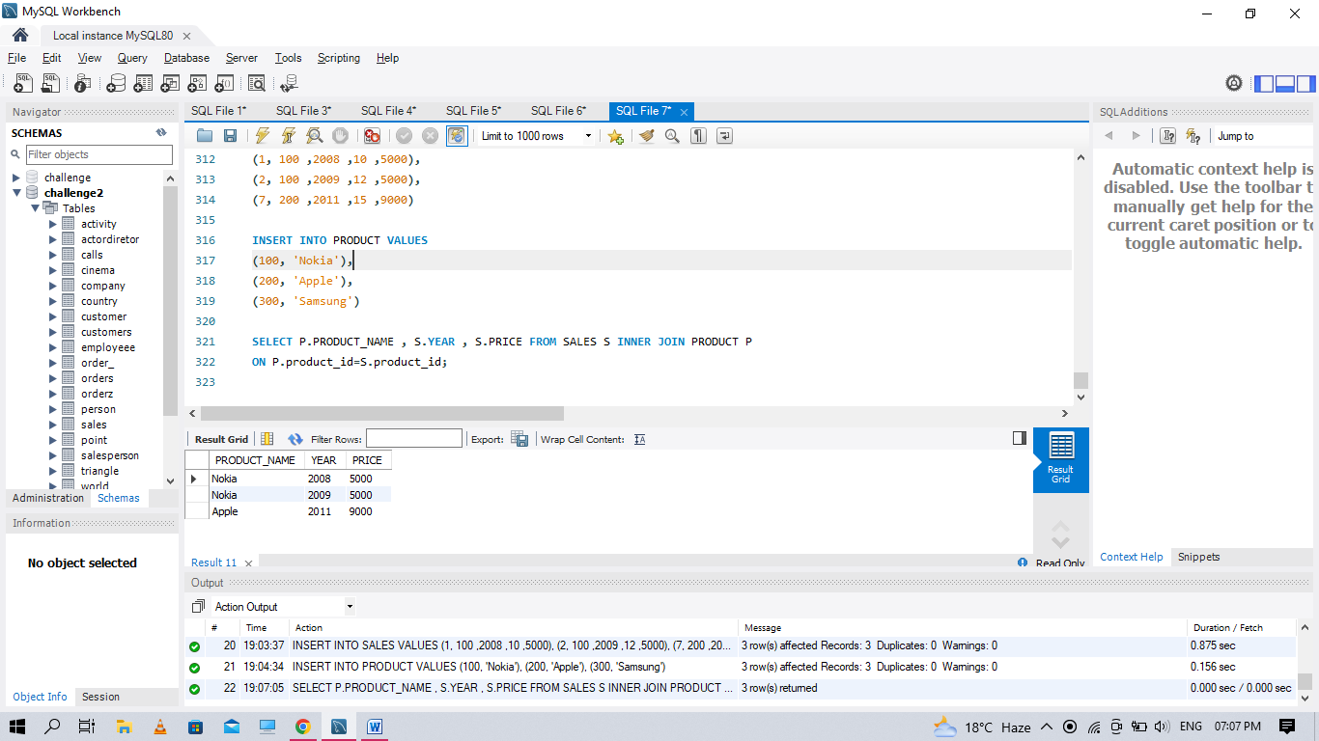

**Q64. Write an SQL query that reports the average experience years of all the employees for each project, rounded to 2 digits**

CREATE TABLE PROJECT

(project_id int,

employee_id int,

PRIMARY KEY (project_id,employee_id))

CREATE TABLE EMPLOYEE

(employee_id int,

name varchar(30),

experience_years int,

PRIMARY KEY(employee_id)

)

INSERT INTO PROJECT VALUES

(1, 1),

(1, 2),

(1 ,3),

(2, 1),

(2, 4)

INSERT INTO EMPLOYEE VALUES

(1, 'Khaled' ,3),

(2, 'Ali',2),

(3, 'John', 1),

(4, 'Doe' ,2)

SELECT P.PROJECT_ID ,ROUND(AVG(experience_years),2)

FROM PROJECT P INNER JOIN EMPLOYEE E

ON P.employee_id=E.employee_id

GROUP BY PROJECT_ID

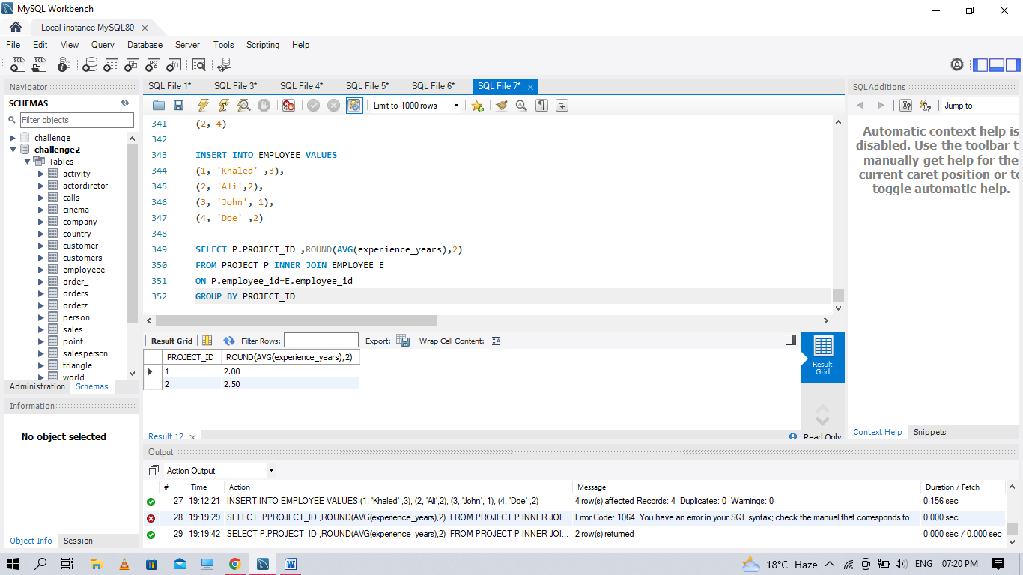

**Q65. Write an SQL query that reports the best seller by total sales price, If there is a tie, report them all. Return the result table in any order.**

CREATE TABLE PRODUCTS

(product_id int,

product_name varchar(30),

unit_price int,

PRIMARY KEY(product_id) )

CREATE TABLE SALE

(seller_id int,

product_id int,

buyer_id int,

sale_date date,

quantity int,

price int,

FOREIGN KEY (product_id) REFERENCES PRODUCTS(product_id))

INSERT INTO PRODUCTS VALUES

(1, 'S8' ,1000),

(2, 'G4' ,800),

(3, 'iPhone', 1400)

INSERT INTO SALE VALUES

(1, 1, 1, '2019-01-21' ,2 ,2000),

(1, 2, 2, '2019-02-17' ,1 ,800),

(2, 2, 3, '2019-06-02' ,1 ,800),

(3, 3, 4, '2019-05-13' ,2 ,2800)

SELECT A.SELLER_ID FROM (

SELECT SELLER_ID , RANK() OVER(ORDER BY SUM(PRICE) DESC) AS RK

FROM SALE

GROUP BY SELLER_ID)A

WHERE RK =1

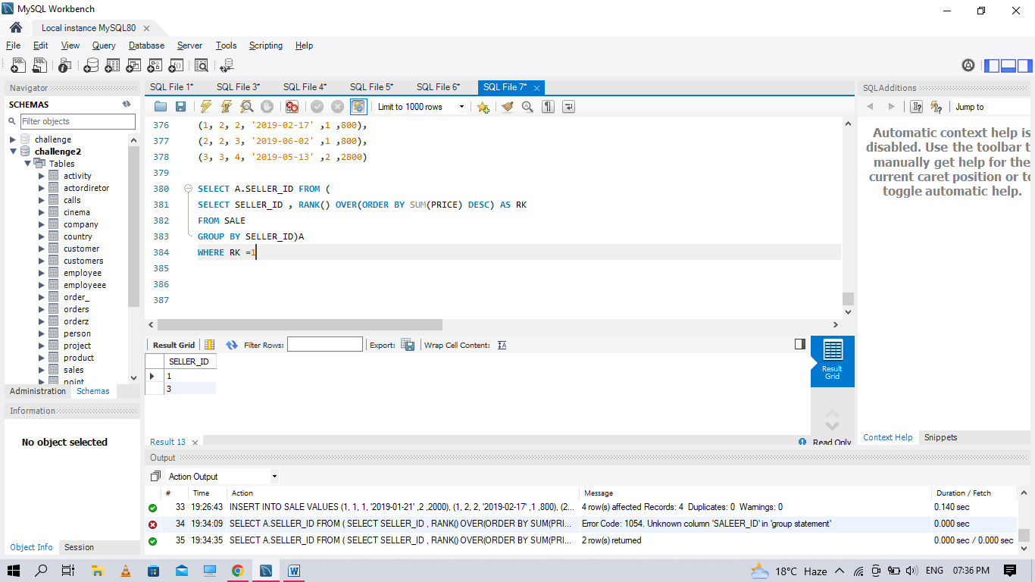

**Q66 Write an SQL query that reports the buyers who have bought S8 but not iPhone. Note that S8 and iPhone are products present in the Product table.**

SELECT S.BUYER_ID FROM SALE S JOIN

PRODUCTS P ON P.PRODUCT_ID=S.PRODUCT_ID

WHERE PRODUCT_NAME = 'S8' AND PRODUCT_NAME <> 'IPHONE'

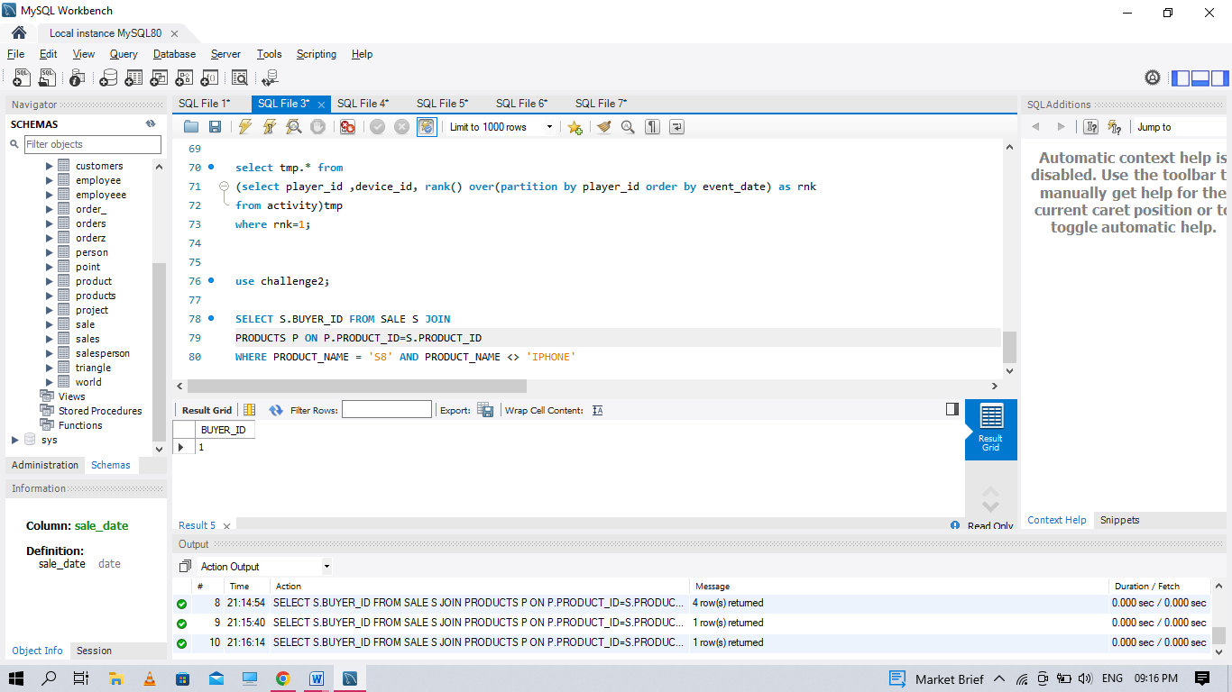

**Q68. Write an SQL query to find the total score for each gender on each day**

CREATE TABLE SCORES

(player_name varchar(30),

gender varchar(30),

day date,

score_points int,

PRIMARY KEY (gender, day)

)

INSERT INTO SCORES VALUES

('Aron', 'F','2020-01-01' ,17),

('Alice' ,'F' ,'2020-01-07' ,23),

('Bajrang', 'M', '2020-01-07' ,7),

('Khali', 'M', '2019-12-25' ,11),

('Slaman', 'M', '2019-12-30' ,13),

('Joe' ,'M' ,'2019-12-31' ,3),

('Jose','M', '2019-12-18' ,2),

('Priya', 'F' ,'2019-12-31' ,23),

('Priyanka' ,'F', '2019-12-30' ,17)

SELECT GENDER , SUM(score_points) OVER(PARTITION BY GENDER ORDER BY DAY) AS SUMS

FROM SCORES

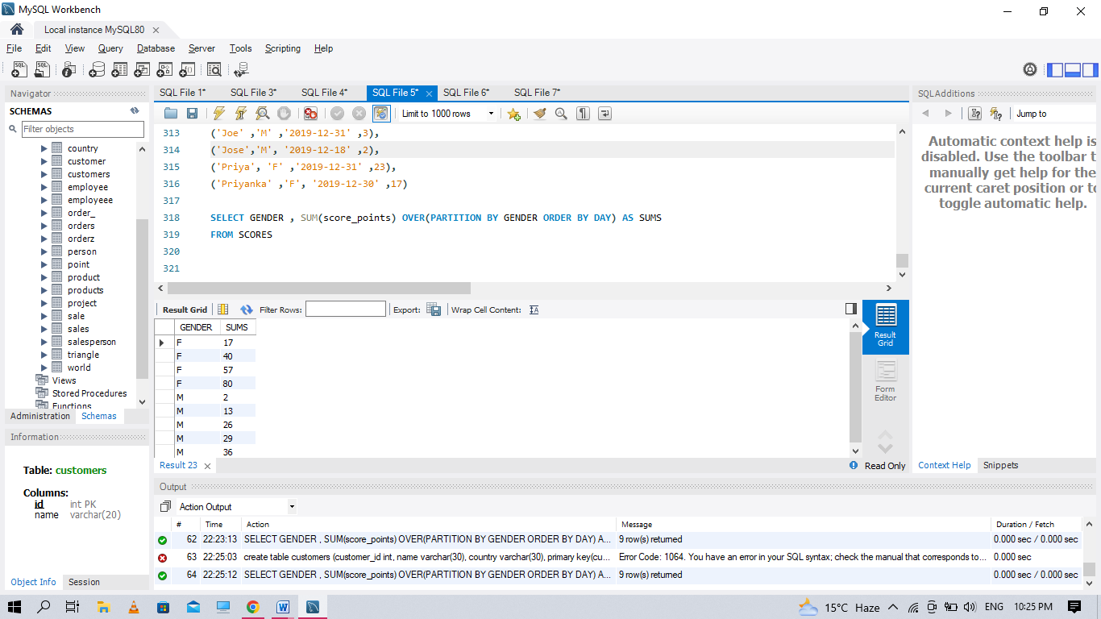

**Q69. Write an SQL query to find the start and end number of continuous ranges in the table Logs. Return the result table ordered by start_id.**

CREATE TABLE LOGS(

log_id int,

PRIMARY KEY (log_id)

)

INSERT INTO LOGS VALUE

(1),

(2),

(3),

(7),

(8),

(10)

SELECT

MIN(log_id) AS start_id,

MAX(log_id) AS end_id

FROM (SELECT

log_id,

log_id - ROW_NUMBER() OVER (ORDER BY log_id) AS rk

FROM Logs) t

GROUP BY rk;

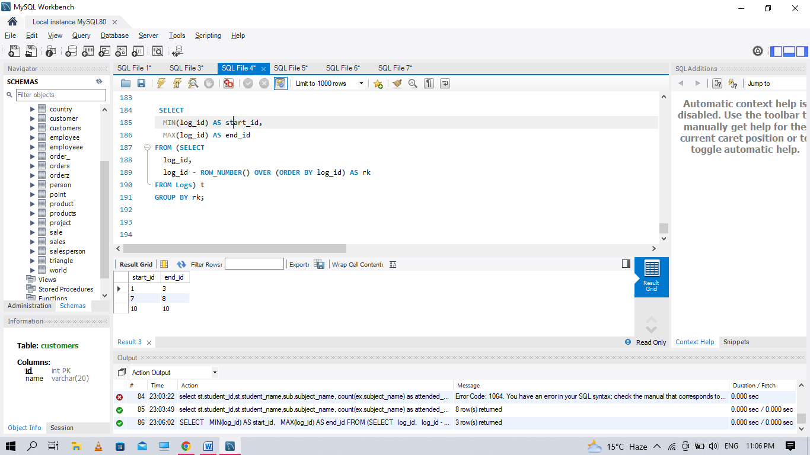

**Q70 .Write an SQL query to find the number of times each student attended each exam**

CREATE TABLE STUDENTS

(student_id int,

student_name varchar(30),

primary key(student_id))

create table subjects(

subject_name varchar(30),

primary key (subject_name)

)

create table examinations

(student_id int,

subject_name varchar(30))

insert into STUDENTS values

(1, 'Alice'),

(2, 'Bob'),

(13,'John'),

(6, 'Alex')

insert into subjects values

( 'Math'),

( 'Physics'),

('Programming')

insert into examinations values

(1, 'Math'),

(1, 'Physics'),

(1, 'Programming'),

(2, 'Programming'),

(1, 'Physics'),

(1, 'Math'),

(13, 'Math'),

(13, 'Programming'),

(13, 'Physics'),

(2, 'Math'),

(1, 'Math')

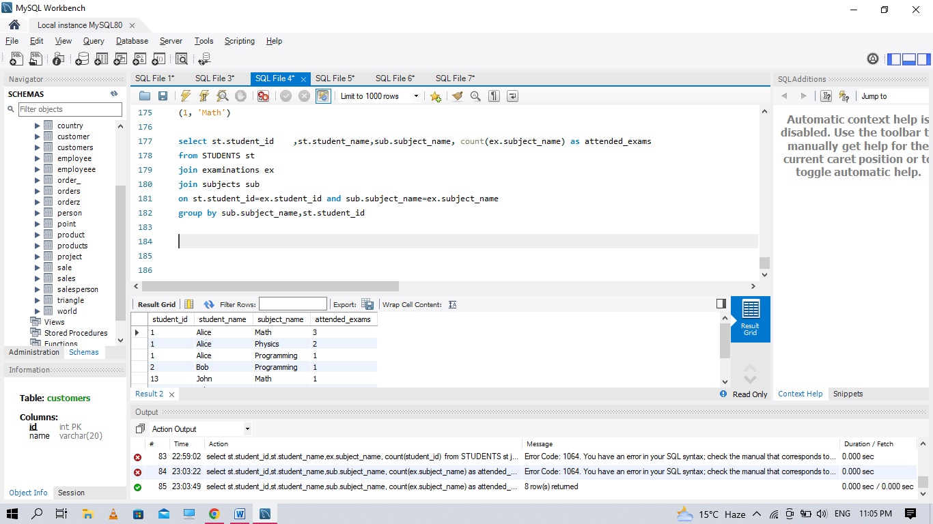

**Q71. Write an SQL query to find employee_id of all employees that directly or indirectly report their work to the head of the company**

create table employees

(employee_id int,

employee_name varchar(30),

manager_id int,

primary key(employee_id)

)

insert into employees values

(1, 'Boss' ,1),

(3, 'Alice' ,3),

(2, 'Bob' ,1),

(4, 'Daniel' ,2),

(7, 'Luis' ,4),

(8, 'Jhon' ,3),

(9, 'Angela' ,8),

(77, 'Robert' ,1)

select a.employee_id as EMPLOYEE_ID

from

Employees as a

join

Employees as b on a.manager_id = b.employee_id

join

Employees as c on b.manager_id = c.employee_id

join

Employees as d on c.manager_id = d.employee_id

where

a.employee_id != 1

and

d.employee_id = 1

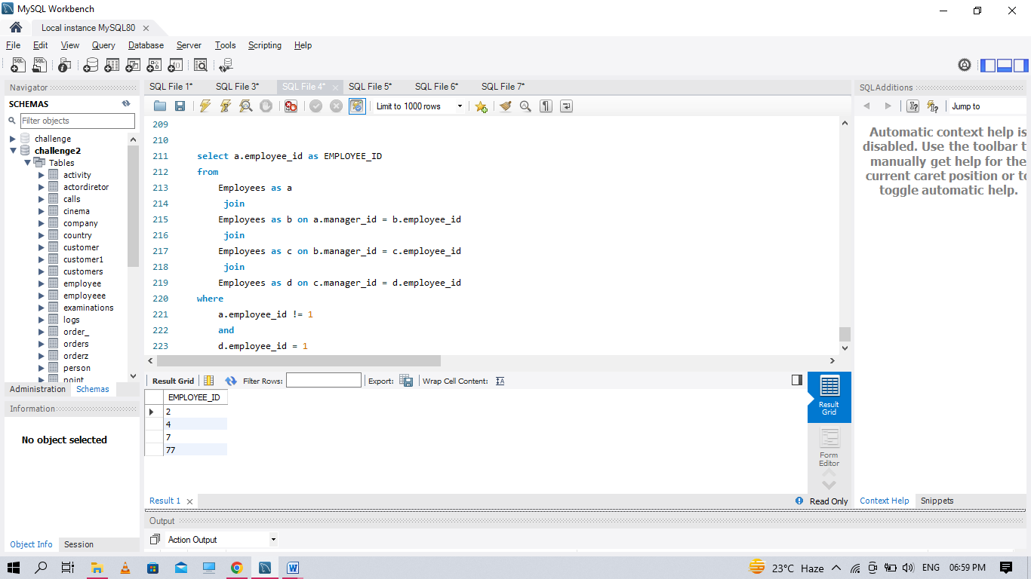

**Q72. Write an SQL query to find for each month and country, the number of transactions and their total amount, the number of approved transactions and their total amount.**

create table transactions

(id int,

country varchar(20),

state enum("approved", "declined"),

amount int,

trans_date date,

primary key(id))

insert into transactions values

(121 ,'US', 'approved' ,1000, '2018-12-18'),

(122 ,'US', 'declined' ,2000 ,'2018-12-19'),

(123 ,'US', 'approved' ,2000 ,'2019-01-01'),

(124 ,'DE', 'approved' ,2000 ,'2019-01-07')

select date_format(trans_date,"%Y-%m") as month, country,

count(id) as trans_count,

sum(case when state='approved' then 1 else 0 end) as approved_count,

sum(amount) as trans_total_amount,

sum(case when state='approved' then amount else 0 end) as approved_total_amount

from transactions

group by month, country

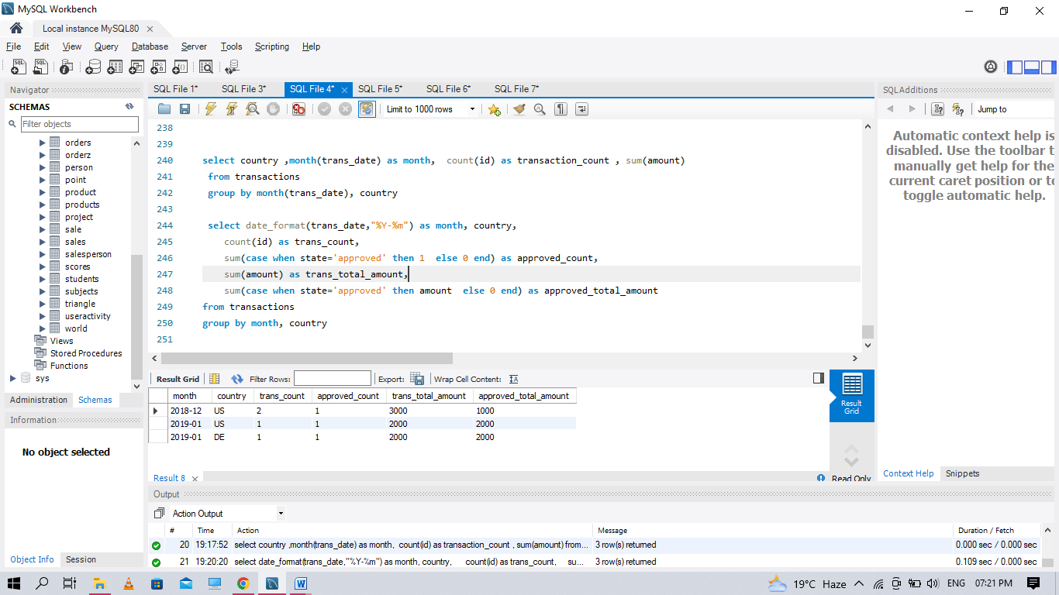

**Q73. Write an SQL query to find the average daily percentage of posts that got removed after being reported as spam, rounded to 2 decimal places.**

create table actions

(user_id int,

post_id int,

action_date date,

action enum('view', 'like', 'reaction', 'comment', 'report', 'share'),

extra varchar(20)

)

create table removal

(post_id int,

remove_date date,

primary key(post_id)

)

insert into actions values

(1, 1, '2019-07-01' ,'view', null),

(1, 1, '2019-07-01' ,'like' ,null),

(1, 1, '2019-07-01' ,'share' ,null),

(2, 2, '2019-07-04' ,'view' ,null),

(2, 2, '2019-07-04' ,'report', 'spam'),

(3, 4, '2019-07-04' ,'view' ,null),

(3, 4, '2019-07-04' ,'report', 'spam'),

(4, 3 ,'2019-07-02' ,'view' ,null),

(4 ,3, '2019-07-02' ,'report' ,'spam'),

(5, 2, '2019-07-03' ,'view', null),

(5, 2, '2019-07-03' ,'report', 'racism'),

(5, 5, '2019-07-03' ,'view', null),

(5, 5, '2019-07-03' ,'report', 'racism')

insert into removal values

(2, '2019-07-20'),

(3 ,'2019-07-18')

select round(avg(daily_count), 2) as average_daily_percent

from (select count(distinct b.post_id)/count(distinct a.post_id)*100 as daily_count

from actions a

left join removal b

on a.post_id = b.post_id

where extra = 'spam'

group by action_date

) b

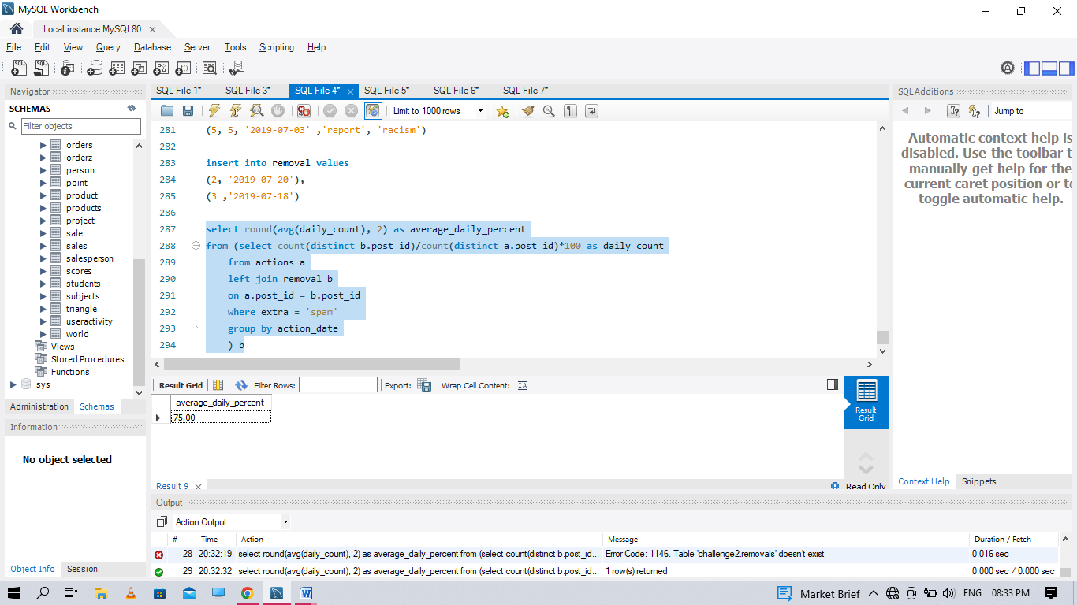

**Q74. Write an SQL query to report the fraction of players that logged in again on the day after the day they first logged in, rounded to 2 decimal places. In other words, you need to count the number of players that logged in for at least two consecutive days starting from their first login date, then divide that number by the total number of players**

create table activity

(

player_id int,

device_id int,

event_date date,

games_played int,

primary key (player_id, event_date)

)

insert into activity values

(1, 2, '2016-03-01' ,5),

(1, 2, '2016-03-02', 6),

(2, 3, '2017-06-25', 1),

(3, 1, '2016-03-02', 0),

(3, 4, '2018-07-03' ,5)

WITH cte AS (

SELECT player_id, MIN(event_date) as first_login

FROM Activity1

GROUP BY player_id

)

SELECT ROUND(SUM(CASE WHEN DATEDIFF(event_date, first_login)=1 THEN 1 ELSE 0 END) / COUNT(DISTINCT cte.player_id), 2) as fraction

FROM Activity1 as a

JOIN cte

ON a.player_id = cte.player_id

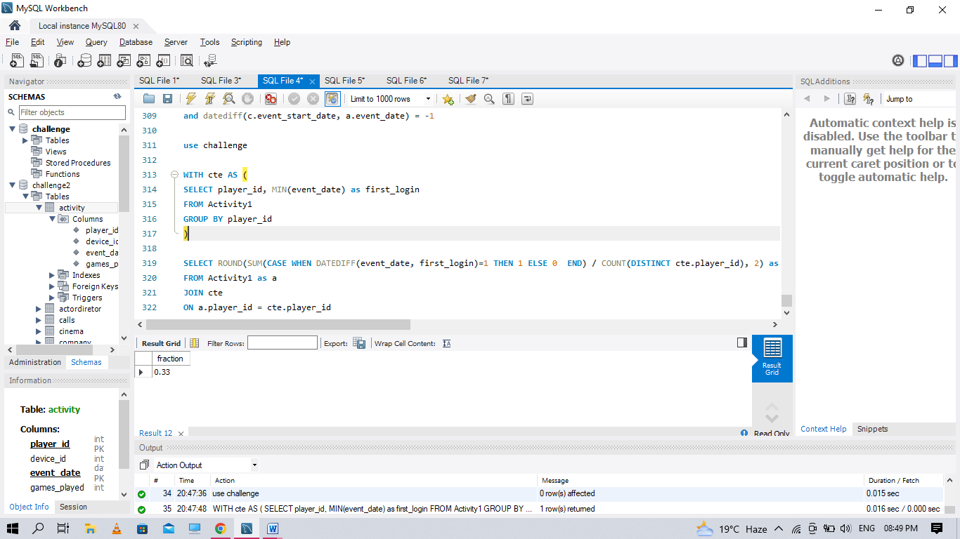

**Q75. Write an SQL query to report the fraction of players that logged in again on the day after the day they first logged in, rounded to 2 decimal places. In other words, you need to count the number of players that logged in for at least two consecutive days starting from their first login date, then divide that number by the total number of players**

create table activity

(

player_id int,

device_id int,

event_date date,

games_played int,

primary key (player_id, event_date)

)

insert into activity values

(1, 2, '2016-03-01' ,5),

(1, 2, '2016-03-02', 6),

(2, 3, '2017-06-25', 1),

(3, 1, '2016-03-02', 0),

(3, 4, '2018-07-03' ,5)

WITH cte AS (

SELECT player_id, MIN(event_date) as first_login

FROM Activity1

GROUP BY player_id

)

SELECT ROUND(SUM(CASE WHEN DATEDIFF(event_date, first_login)=1 THEN 1 ELSE 0 END) / COUNT(DISTINCT cte.player_id), 2) as fraction

FROM Activity1 as a

JOIN cte

ON a.player_id = cte.player_id



**Q76 Write an SQL query to find the salaries of the employees after applying taxes. Round the salary to the nearest integer**

create table salaries

(company_id int,

employee_id int,

employee_name varchar(30),

salary int,

primary key(company_id, employee_id) )

insert into salaries values

(1, 1, 'Tony',2000),

(1, 2, 'Pronub' ,21300),

(1, 3, 'Tyrrox' ,10800),

(2, 1, 'Pam' ,300),

(2, 7, 'Bassem' ,450),

(2, 9, 'Hermione' ,700),

(3, 7, 'Bocaben' ,100),

(3, 2, 'Ognjen' ,2200),

(3, 13, 'Nyan Cat' ,3300),

(3, 15, 'Morning Cat' ,7777)

select company_id, employee_id, employee_name, round(salary - salary*tax, 0) as salary

from

(

select *,

case when max(salary) over(partition by company_id) < 1000 then 0

when max(salary) over(partition by company_id) between 1000

and 10000 then 0.24

else 0.49 end as tax

from Salaries

) x

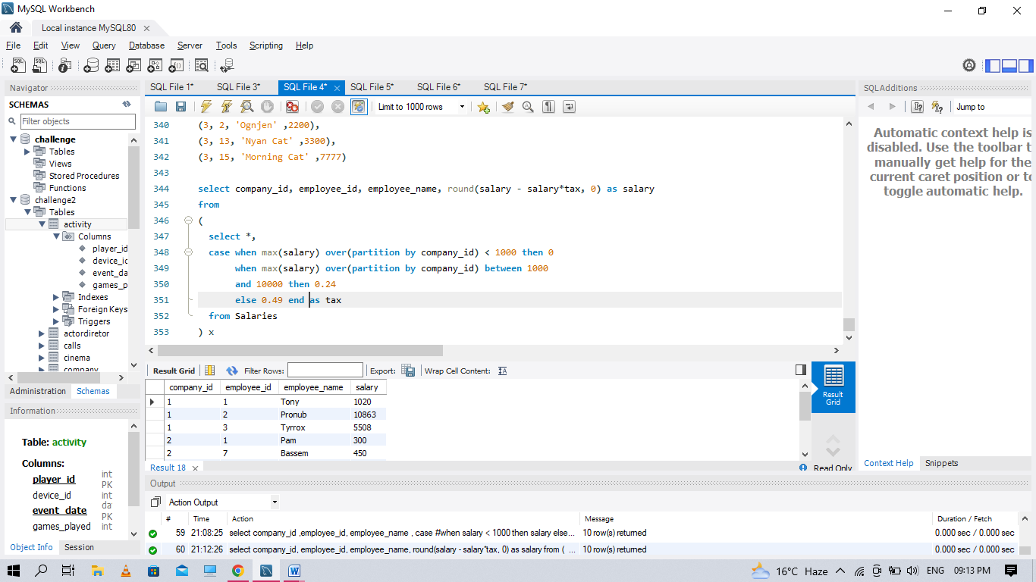

**Q77 Write an SQL query to evaluate the boolean expressions in Expressions table**

CREATE TABLE EXPRESSIONS

(left_operand varchar(5),

operator enum('<', '>', '='),

right_operand varchar(5),

PRIMARY KEY (left_operand, operator, right_operand))

CREATE TABLE VARIABLE

(name varchar(10),

value int,

primary key(NAME)

)

INSERT INTO VARIABLE VALUES

('x' ,66),

('y' ,77)

INSERT INTO EXPRESSIONS VALUES

('x', '>', 'y' ),

('x', '<','y' ),

('x', '=', 'y' ),

('y', '>', 'x'),

('y', '<', 'x'),

('x', '=', 'x')

select e.left_operand, e.operator, e.right_operand,

case when

e.operator = '<' then if(l.value < r.value, 'true', 'false')

when e.operator = '>' then if(l.value > r.value, 'true', 'false')

else if(l.value = r.value, 'true', 'false') end

as value

from Expressions e

join Variable l

on e.left_operand = l.name

join Variable r

on e.right_operand = r.name

;

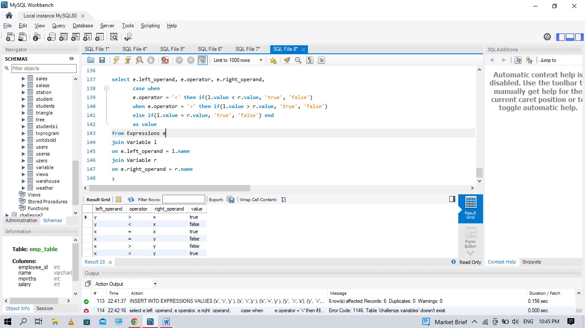

**Q78. Write an SQL query to find the countries where this company can invest. Return the result table in any order.**

create table person

(

id int,

name varchar(20),

phone_number varchar(20),

primary key(id)

)

create table country

(

name varchar(20),

country_code varchar(20),

primary key(country_code)

)

create table calls

(caller_id int,

callee_id int,

duration int

)

insert into person values

(3 ,'Jonathan', '051-1234567'),

(12 ,'Elvis' ,'051-7654321'),

(1 ,'Moncef' ,'212-1234567'),

(2 ,'Maroua' ,'212-6523651'),

(7 ,'Meir' ,'972-1234567'),

(9 ,'Rachel' ,'972-0011100')

insert into country values

('Peru' ,'51'),

('Israel' ,'972'),

('Morocco' ,'212'),

('Germany' ,'49'),

('Ethiopia' ,'251')

insert into calls values

(1 ,9 ,33),

(2 ,9 ,4),

(1 ,2 ,59),

(3 ,12 ,102),

(3 ,12 ,330),

(12 ,3 ,5),

(7 ,9 ,13),

(7 ,1 ,3),

(9 ,7 ,1),

(1 ,7 ,7)

select c.name as country

from Person p

inner join Country c

on left (p.phone_number,3) = c.country_code

inner join (select caller_id as id, duration

from Calls

union all

select callee_id as id, duration

from Calls) phn

on p.id = phn.id

group by country

having avg(duration) > (select avg(duration) from Calls)

**Q79. Write a query that prints a list of employee names (i.e.: the name attribute) from the Employee table in alphabetical order.**

SELECT NAME FROM EMP_TABLE ORDER BY NAME ASC;

create table emp_table

(employee_id int,

name varchar(30),

months int,

salary int)

insert into emp_table values

(12228,'rose',15,1968),

(33645,'angelina',1,3443),

(45692,'frank',17,1608),

(56118,'patrik',7,1345),

(59725,'lisa',11,2330),

(74197,'kimberly',16,4372),

(78454,'bonnie',8,1771),

(83565,'michael',6,2017),

(98607,'todd',5,3396),

(99989,'joe',9,3573)

